**IHG Hotels & Resorts grows Luxury & Lifestyle**  
**collection in Montenegro**

*The stunning InterContinental Resort Amma, Canj - Montenegro will open in 2023*

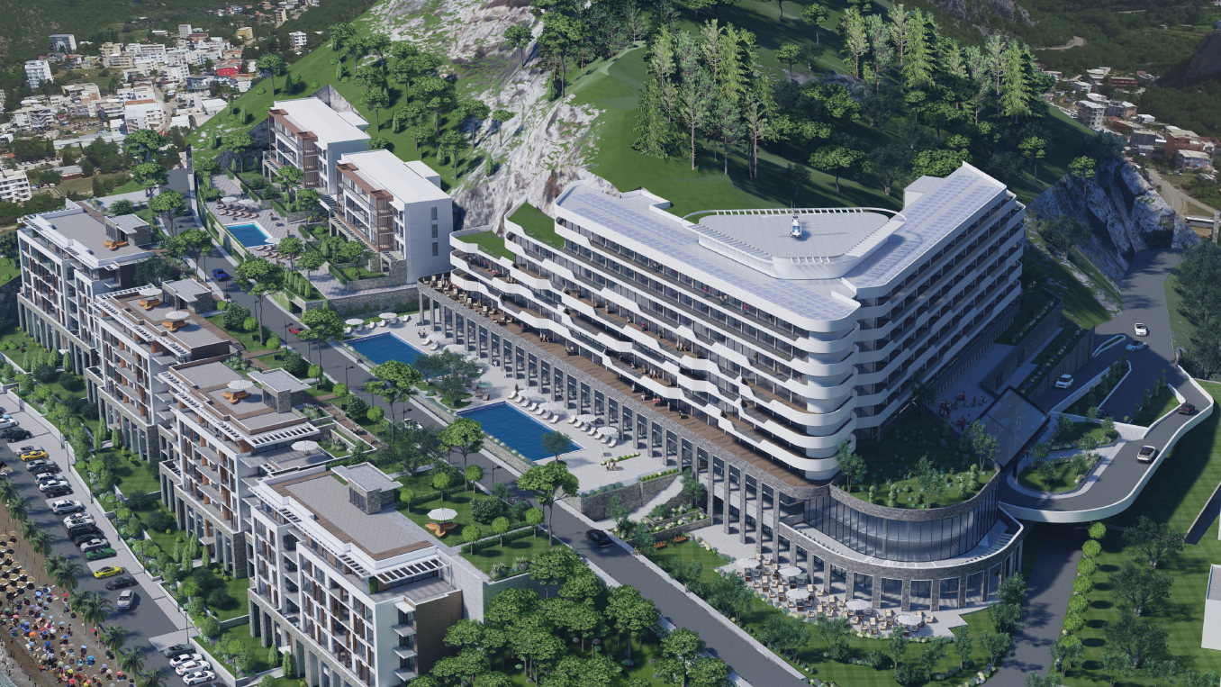

(Current rendering of exterior)

(22 July 2021) IHG® Hotels & Resorts (IHG®) is proud to announce a franchise agreement with Celebic Group, one of Montenegro’s largest real estate development companies, to open **InterContinental® Resort Amma, Canj – Montenegro** in autumn 2023.

The stunning new hotel will be the first for the InterContinental brand in the market, and will join its IHG-sister property Regent Porto Montenegro in providing guests with a luxury destination overlooking the beautiful Adriatic seafront. It will be perfectly located on the Biserna Obala (Pearl Coast), part of a 1200m-long unspoiled coastline sheltered by wooded, rocky hills traditionally popular with locals and visitors alike.

InterContinental Resort Amma, Canj – Montenegro will offer leisure and business guests a choice of 198 rooms, including 60 suites, alongside a selection of villas and a significant luxury residential development.

A sun-drenched swimming pool with its own bar, indoor and outdoor wellness facilities, a fully-equipped fitness centre, and a spa with four treatment rooms and three saunas will ensure every visitor finds a way to rest, relax and unwind during their stay.

When it comes to dining, InterContinental Resort Amma, Canj – Montenegro will boast a world-class main restaurant and rooftop bar, as well as a more intimate club lounge. There will be plentiful meeting rooms – including a ballroom – for those guests looking to take care of business, as well as underground parking with 260 spaces.

**(Mrs) Willemijn Geels, Vice President Development Europe, IHG Hotels & Resorts**, said: “InterContinental Hotels & Resorts is one of the world’s best-known luxury global travel brands, and as we celebrate its 75th anniversary this year, we’re delighted to sign an agreement with Celebic Group to welcome InterContinental Resort Amma, Canj – Montenegro into our growing Lifestyle & Luxury Collection.

“At IHG Hotels & Resorts, we are proud to have a positive, assured brand presence in the Balkan countries and we consider Celebic Group to be the ideal partner as we continue our growth in the region throughout the next few years.

“The opening of InterContinental Resort Amma, Canj – Montenegro, anticipated for autumn 2023, adds further momentum to our recent expansion in the Balkans, which saw voco Podgorica welcome guests through its doors in2020, and the signing of Holiday Inn Express Podgorica, which is set to open towards the end of this year, also in partnership with Celebic Group.”

The idyllic tourist town of Canj is located in southern Montenegro, one of Europe's fast-growing luxury leisure markets thanks to its eye-catching coastline, sprawling beaches and easy access to Dubrovnik in southern Croatia.

**Mr. Goran Darmanovic, Advisor to the President at Celebic Group added**: “We are pleased to expand our long-standing partnership with IHG Hotels & Resorts with the signing of InterContinental Resort Amma, Canj – Montenegro.

“The hotel will be the first branded property in Canj and presents a strong opportunity to attract visitors to the town, coupled with the introduction of a luxury residential development as part of the project.”

InterContinental Hotels & Resorts is the world’s largest luxury hotel brand and this year celebrates its 75th anniversary. Each of its hotels is a destination in its own right with a distinctive style and ambience, from historic buildings to modern city landmarks and captivating resorts in every corner of the globe.

InterContinental Resort Amma, Canj – Montenegro will form part of IHG Hotels & Resorts’ powerful Luxury & Lifestyle Collection, which includes: Six Senses Hotels Resorts Spas, Regent Hotels & Resorts, InterContinental Hotels & Resorts Kimpton Hotels & Restaurants, and Hotel Indigo. The InterContinental Hotels & Resorts brand currently has 33 open hotels across Europe, with a further five in its development pipeline in countries including Turkey, Italy, France, Israel and Azerbaijan.\*

*\*figures correct as at 31 March 2021*

**Ends**

**Notes to editors**

[IHG Hotels & Resorts](https://www.ihgplc.com/) [LON:IHG, NYSE:IHG (ADRs)] is a global hospitality company, with a purpose to provide True Hospitality for Good.

With a family of 16 hotel brands and [IHG Rewards](http://www.ihg.com/rewardsclub/gb/en/home), one of the world’s largest hotel loyalty programmes, IHG has nearly 6,000 open hotels in more than 100 countries, and a further 1,800 in the development pipeline.

* **Premium:** [HUALUXE Hotels & Resorts](https://www.ihg.com/hualuxe/hotels/gb/en/reservation), [Crowne PlazaHotels & Resorts](http://www.ihg.com/crowneplaza/hotels/gb/en/reservation), [EVEN Hotels](http://www.ihg.com/evenhotels/hotels/us/en/reservation), [voco Hotels](https://www.ihg.com/voco/hotels/gb/en/reservation" \t "_blank)
* **Luxury and lifestyle:** [Six Senses Hotels Resorts Spas](https://www.sixsenses.com/), [Regent Hotels & Resorts](https://www.regenthotels.com/), [InterContinental Hotels & Resorts](http://www.intercontinental.com/hotels/gb/en/reservation), [Kimpton Hotels & Restaurants](https://www.ihg.com/kimptonhotels/hotels/gb/en/reservation), [Hotel Indigo](http://www.ihg.com/hotelindigo/hotels/gb/en/reservation)
* **Essentials:** [Holiday Inn Hotels & Resorts](http://www.ihg.com/holidayinn/hotels/gb/en/reservation), [Holiday Inn Express](http://www.ihg.com/holidayinnexpress/hotels/gb/en/reservation), [avid hotels](https://www.ihg.com/avidhotels/hotels/us/en/reservation)
* **Suites:**[Atwell Suites](https://www.atwellsuites.com/), [Staybridge Suites](http://www.ihg.com/staybridge/hotels/gb/en/reservation),  [Holiday Inn Club Vacations](https://www.ihg.com/holidayinnclubvacations/hotels/us/en/reservation), [Candlewood Suites](http://www.ihg.com/candlewood/hotels/us/en/reservation)

InterContinental Hotels Group PLC is the Group’s holding company and is incorporated in Great Britain and registered in England and Wales. Approximately 350,000 people work across IHG’s hotels and corporate offices globally.

Visit us online for more about our [hotels and reservations](http://www.ihg.com/) and [IHG Rewards](https://www.ihg.com/rewardsclub/content/gb/en/home). For our latest news, visit our [Newsroom](https://www.ihgplc.com/en/news-and-media) and follow us on [LinkedIn](https://www.linkedin.com/company/ihghotels&resorts/), [Facebook](http://www.facebook.com/ihgcorporate) and [Twitter](http://www.twitter.com/IHGCorporate).